CodingBat String-3: countYZ

Start of the debugging, breakpoint is set at line 5 and we will step into the countYZ method:

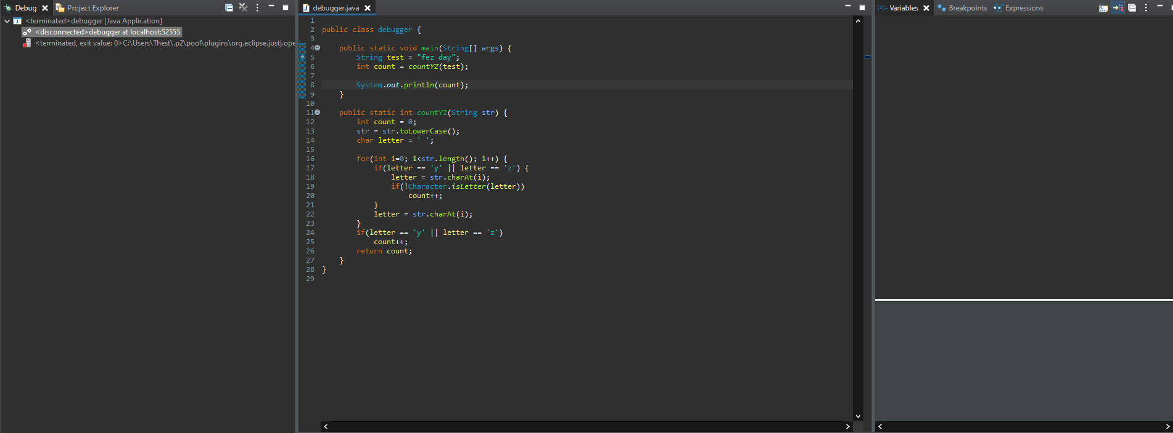

Stepped into countYZ method:

